JUNE 14TH 2021 ANSWERS

THIS WEEK’S THEME
This week’s theme is Remember the Seventies? We feature the films, the stars, the music and the fashions of the years 1970-1979
THIS WEEK’S TRANSATLANTIC SESSIONS
We are having another session with our friends in Dementia Friendly Fort Worth in Texas on Thursday June 17th, starting at 4.30 pm. I will post out the link later this week. Thanks to those of you who joined the Hummingbird Café in New Mexico last week. The café members really enjoyed the session and Nicolette e-mailed to say “It was so nice to hear and see all of our Scottish friends on screen.”
ON THE HOME FRONT
On Friday June 18th, we are hosting the monthly session with the Friday Feeling group in Forth Valley where we will be doing a Screen Memories session on Film stars “out of their comfort zone.”
SWEDE DREAMS
The super-group of the 70s. What was the name of their song which won the Eurovision Song Contest in 1974?
WATERLOO.

BAND ON THE RUN?
What was the name of this band and what was their No.1 hit in 1972?
THE BAND OF THE ROYAL SCOTS DRAGOON GUARDS.AMAZING GRACE.
MUSICAL SUCCESS
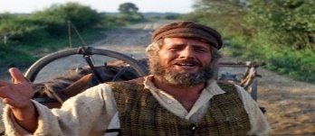
This film came out in 1971. What was it and who is the star shown here?
FIDDLER ON THE ROOF. TOPOL.
OSCAR NOMINEE
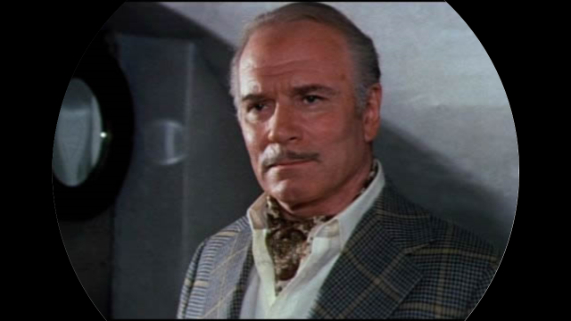
Who is this British actor who starred in the film Sleuth along with Michael Caine? LAURENCE OLIVIER
SUPREME PERFORMANCE?
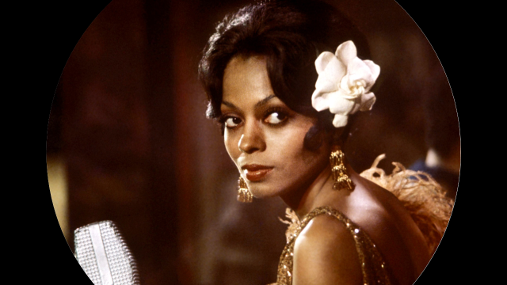
Another Oscar-nominated star. Who is she and who did she play in the film “Lady Sings the Blues”?
DIANA ROSS. BILLIE HOLIDAY

MILITARY PRECISION
Can you name the actor and the character he is portraying here?
GEORGE C. SCOTT.GENERAL GEORGE PATTON.
SEVENTIES STARS
What was the name of this group who had several chart successes in the 1970s?
BONEY M.
CITY SLICKERS?
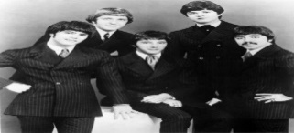
Who are this American group who had a big hit with If You Leave Me Now?
CHICAGO
THE FRENCH CONNECTION
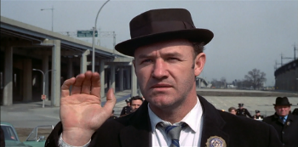
Who is the actor and what was the nickname of the character he played in the film – Mickey, Popeye, Goofy, or Felix?
GENE HACKMAN.POPEYE.

LOOKING BACK
Who are the two stars shown here and what was the name of the Oscar-nominated film in which they co-starred?
BARBRA STREISAND and ROBERT REDFORD.THE WAY WE WERE.
SAILING
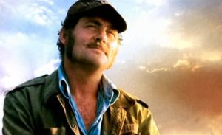
Which 70s film is this and who is the British actor?
JAWS.ROBERT SHAW.
THE SUNSHINE BOYS
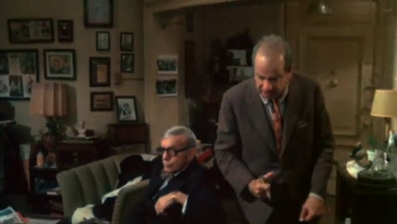
Who were the two actors playing the title roles?
GEORGE BURNS and WALTER MATTHAU.
MULTI-OSCAR NOMINEE
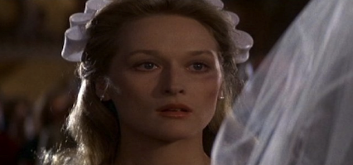
Nominated in 1978 for Best Supporting Actress. Who is she and what film was this? MERYL STREEP.THE DEER HUNTER.

A MAN OF MANY PARTS
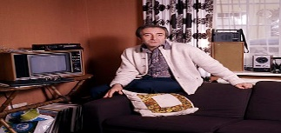
Who is this British actor and in which 1979 film did he play the part of a gardener called Chance?
PETER SELLERS. BEING THERE.
THE BOYS FROM BRAZIL
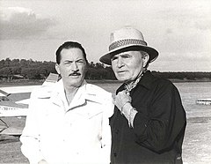
A film about Nazi exiles in South America featured a strong cast. Who are the two actors shown here?
GREGORY PECK and JAMES MASON.
TAXI!
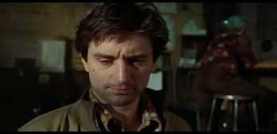
Who is the actor shown here and what was his character called- the initials are T.B.?
ROBERT DE NIRO. TRAVIS BICKLE.
1974 VERSION
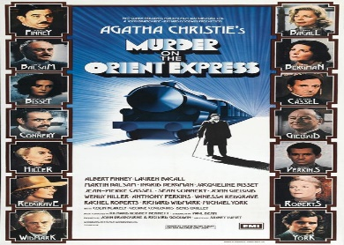
Which of the cast won an Oscar for her role in this film as Mrs. Hubbard?
INGRID BERGMAN.

TOP OF THE POPS
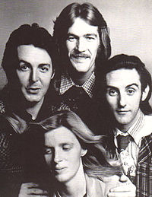
What was the name of this band and which Scottish location featured on one of their No 1 hits?
PAUL McCARTNEY and WINGS. MULL OF KINTYRE.
SERPICO
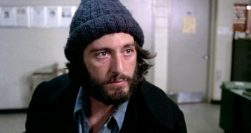
Who is the actor who played the part of the undercover policeman in the film version?
AL PACINO.
SAVE THE TIGER
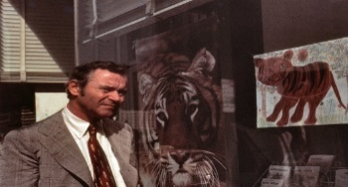
Who is this Oscar-nominated actor?
JACK LEMMON
AWARD-WINNING FILM
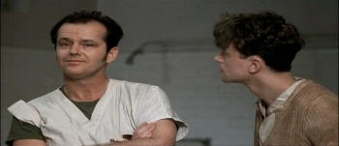
Who is the actor on the left and what is the title of this film?
JACK NICHOLSON. ONE FLEW OVER THE CUCKOO’S NEST.

