Screen Memories Review
June 21st . 2021

THIS WEEK’S THEME
This week’s theme is Colours. We feature films with the name of a colour in the title, as well as songs that also had colours in their name.
THIS WEEK’S TRANSATLANTIC SESSIONS
We are having another session with our friends in Pennswood, Pennsylvania on Friday June 25th starting at 3.00 p.m. our time. I will send out the link as soon as I have it.
ON THE HOME FRONT
On Monday June 21st we are with West Dunbartonshire and then at East Ayrshire on Tuesday June 22nd. In a very busy week, we are with the Fife group on Thursday June 24th.
FEMME FATALE
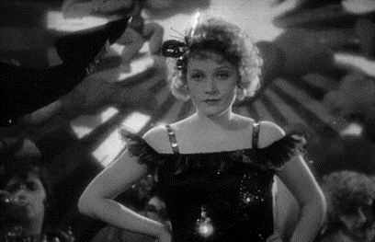
Who is this star and what was the name of her famous German film from 1930? MARLENE DIETRICH.THE BLUE ANGEL
DANCE, DANCE, DANCE
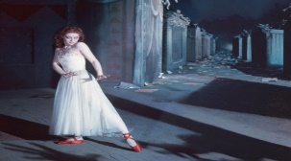
What was the name of this film and who was the female lead? THE RED SHOES.MOIRA SHEARER.

FOR VALOUR
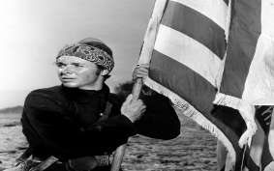
Who is this soldier who became an actor, and what was the name of his film with a colour in its title? AUDIE MURPHY. THE RED BADGE OF COURAGE.
SINGIN’ THE BLUES?
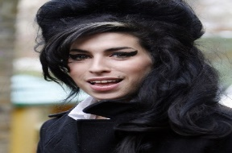
Who is the singer and what was the title of her hit single referring to a colour reversion? AMY WINEHOUSE. BACK TO BLACK.
VERY POPULAR STAR
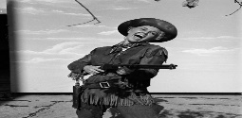
Who is she and which hills did she sing about in the film Calamity Jane? DORIS DAY. THE BLACK HILLS OF DAKOTA.

50s STAR
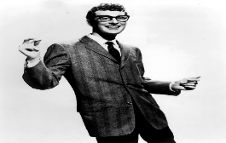
Who is the singer and which of his songs contained the words “Flying across the desert in a TWA, I saw a woman walking across the sand…...?” BUDDY HOLLY. BROWN-EYED HANDSOME MAN.
FILM STARS?
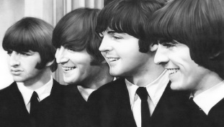
Which of their films contained the name of a colour? YELLOW SUBMARINE.
WILDER BY THE MINUTE
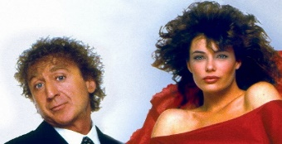
What was the name of this film and what was the Stevie Wonder hit associated with it? WOMAN IN RED. I JUST CALLED TO SAY I LOVE YOU.
MASTER OF HORROR
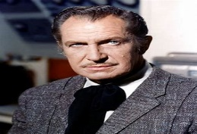
Who is he and what is the missing colour in the title of his 1964 film- The Masque of the * Death”? VINCENT PRICE. RED.
DIAMOND GEEZERS?
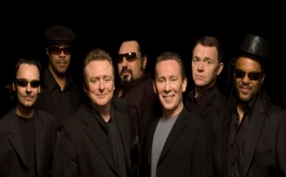
Who are these guys and what was the colour of the wine in their 1983 cover of a Neil Diamond hit? UB 40. RED
MADE IT MA! TOP OF THE WORLD!
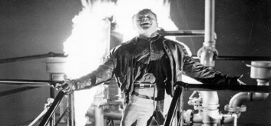
Who is the actor and which of his films is shown here? JAMES CAGNEY. WHITE HEAT.
MURDER SUSPECT
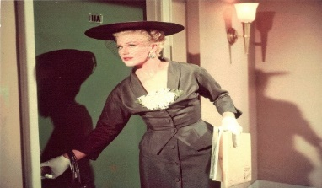
Who is this actress and what was the name of this film - Red Widow, Black Widow or Green Widow? GINGER ROGERS. BLACK WIDOW.
THE COLOUR OF LOVE?
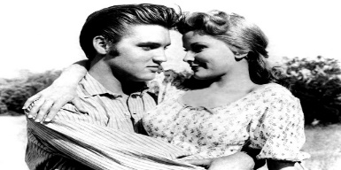
Which two Elvis Presley films have a colour in the title? BLUE HAWAII.G.I. BLUES.
GRAVEYARD SEARCH
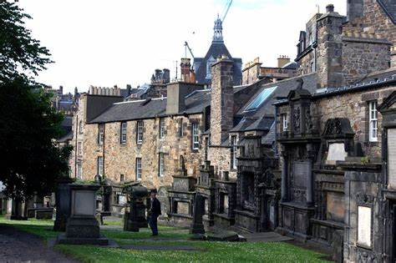
An Edinburgh churchyard with a nearby statue of a famous dog. The dog featured in a 1961 Walt Disney film. What was its name? GREYFRIARS BOBBY.
DREAMING?
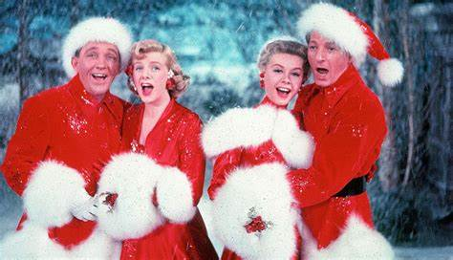
What is the name of the film and who are the four stars shown here? WHITE CHRISTMAS. BING CROSBY, DANNY KAYE, VERA-ELLEN, ROSEMARY CLOONEY.

EVENIN’ ALL
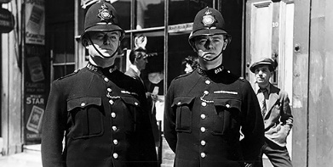
A 1950 film that starred Dirk Bogarde as a villain. Who is the actor on the left and which long-running TV series on BBC TV was developed from the film? JACK WARNER. DIXON OF DOCK GREEN.
COLOURFUL STARS
Complete the names of these stars
JACK BLACK
RICHARD GREENE
CAROL WHITE
COLOURFUL TITLES
What is the missing colour in these film titles?
1953 The RED Beret
2002 RED Dragon
1980 BLUE Lagoon
1957 BLUE Murder at St.Trinians
1992 WHITE Men Can’t Jump
1999 The GREEN Mile

TRANSATLANTIC JUKEBOX DAYS
TOP OF THE COLOURFUL POPS
Complete the title of these songs by adding a colour.
Mellow YELLOW (Donovan)
GREEN, GREEN Grass of Home (Tom Jones)
Tie a YELLOW Ribbon (Tony Orlando and Dawn)
BLUE Bayou (Roy Orbison)
Big YELLOW Taxi (Joni Mitchell)
99 RED Balloons (Nina)
Mr. BLUE Skies (E.L.O.)
COLOURFUL GROUP
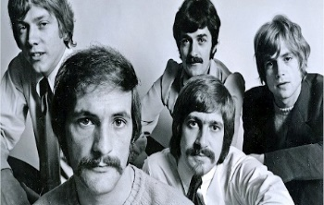
What is the name of this group seen here in 1968? MOODY BLUES
AS THEY ARE
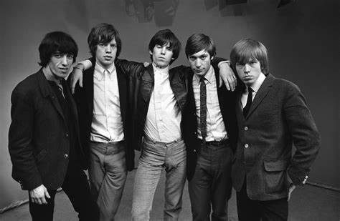
Which of their hits has the name of a colour in the title? PAINT IT BLACK, BROWN SUGAR, LITTLE RED ROOSTER, RUBY (?), SWEET BLACK ANGEL.

Sharing Rock and Roll Memories.

