Screen Memories Review
June 14th . 2021

THIS WEEK’S THEME
This week’s theme is Remember the Seventies? We feature the films, the stars, the music and the fashions of the years 1970-1979
THIS WEEK’S TRANSATLANTIC SESSIONS
We are having another session with our friends in Dementia Friendly Fort Worth in Texas on Thursday June 17th, starting at 4.30 pm. I will post out the link later this week. Thanks to those of you who joined the Hummingbird Café in New Mexico last week. The café members really enjoyed the session and Nicolette e-mailed to say “It was so nice to hear and see all of our Scottish friends on screen.”
ON THE HOME FRONT
On Friday June 18th, we are hosting the monthly session with the Friday Feeling group in Forth Valley where we will be doing a Screen Memories session on Film stars “out of their comfort zone.”
SWEDE DREAMS
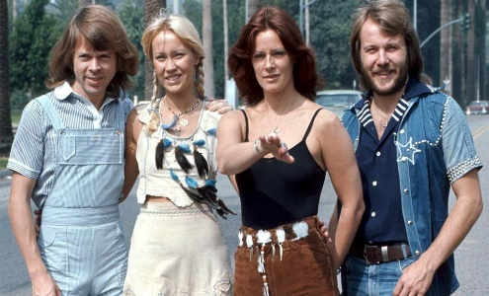
The super-group of the 70s. What was the name of their song which won the Eurovision Song Contest in 1974?

BAND ON THE RUN?
What was the name of this band and what was their No.1 hit in 1972?
MUSICAL SUCCESS
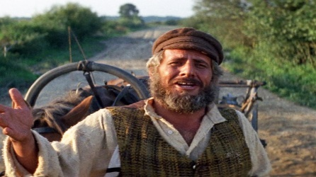
This film came out in 1971. What was it and who is the star shown here?
OSCAR NOMINEE
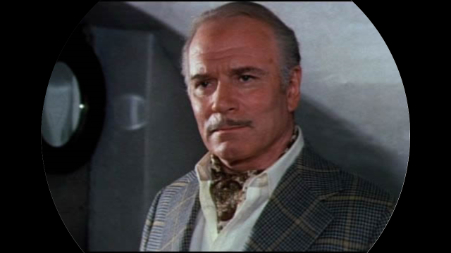
Who is this British actor who starred in the film Sleuth along with Michael Caine?
SUPREME PERFORMANCE?
Another Oscar-nominated star. Who is she and who did she play in the film “Lady Sings the Blues”?
MILITARY PRECISION
Can you name the actor and the character he is portraying here?
SEVENTIES STARS
What was the name of this group who had several chart successes in the 1970s?
CITY SLICKERS?
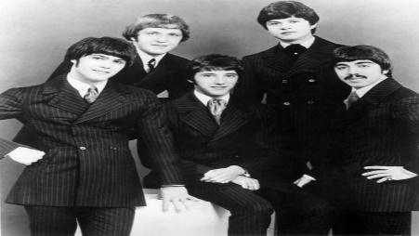
Who are this American group who had a big hit with If You Leave Me Now?

THE FRENCH CONNECTION
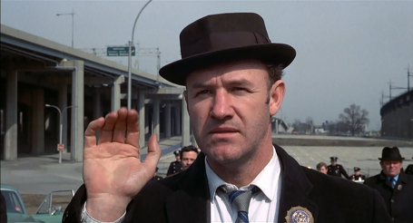
Who is the actor and what was the nickname of the character he played in the film – Mickey, Popeye, Goofy, or Felix?
LOOKING BACK
Who are the two stars shown here and what was the name of the Oscar-nominated film in which they co-starred?
SAILING
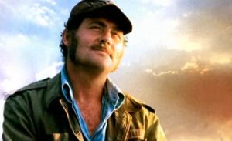
Which 70s film is this and who is the British actor?
THE SUNSHINE BOYS
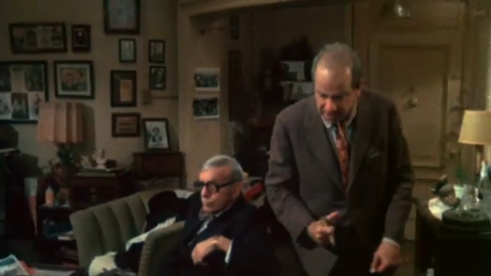
Who were the two actors playing the title roles?
MULTI-OSCAR NOMINEE
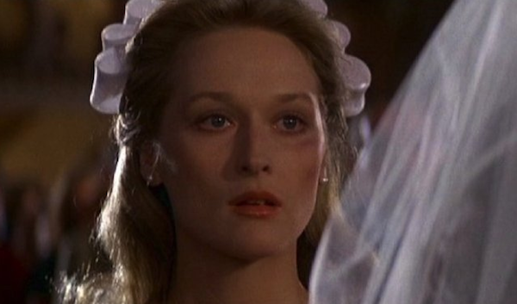
Nominated in 1978 for Best Supporting Actress. Who is she and what film was this?
A MAN OF MANY PARTS
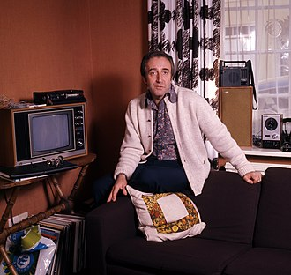
Who is this British actor and in which 1979 film did he play the part of a gardener called Chance?
THE BOYS FROM BRAZIL
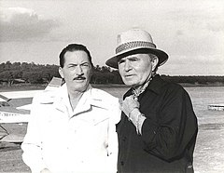
A film about Nazi exiles in South America featured a strong cast. Who are the two actors shown here?
TAXI!
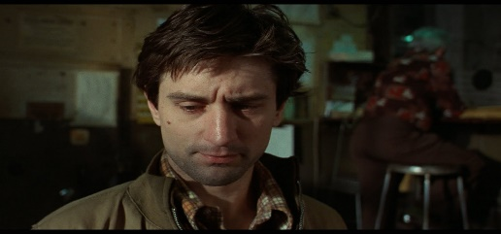
Who is the actor shown here and what was his character called- the initials are T.B.?
1974 VERSION
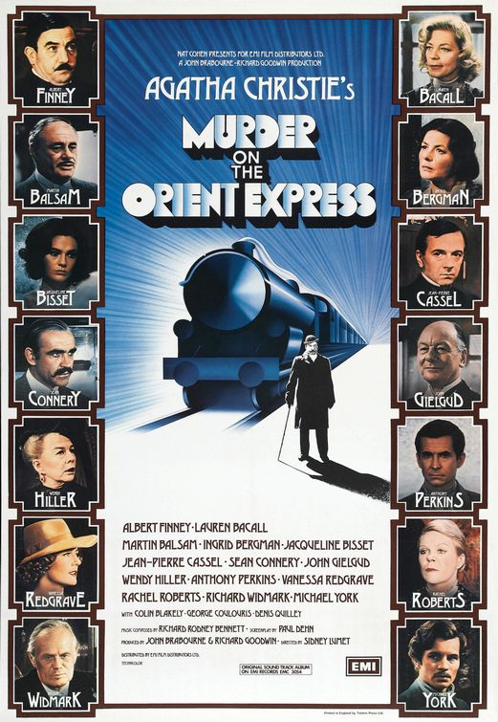
Which of the cast won an Oscar for her role in this film as Mrs. Hubbard?
TOP OF THE POPS
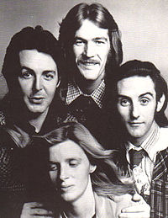
What was the name of this band and which Scottish location featured on one of their No 1 hits?
SERPICO
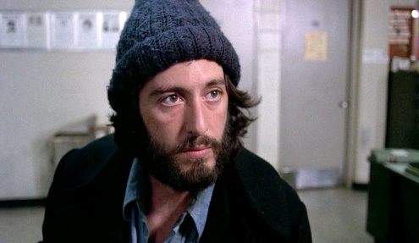
Who is the actor who played the part of the undercover policeman in the film version?
SAVE THE TIGER
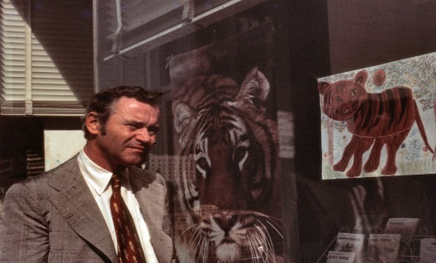
Who is this Oscar-nominated actor?
AWARD-WINNING FILM
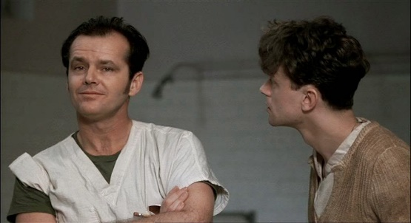
Who is the actor on the left and what is the title of this film?

