Screen Memories Review
June 21st . 2021

THIS WEEK’S THEME
This week’s theme is Colours. We feature films with the name of a colour in the title, as well as songs that also had colours in their name.
THIS WEEK’S TRANSATLANTIC SESSIONS
We are having another session with our friends in Pennswood, Pennsylvania on Friday June 25th starting at 3.00 p.m. our time. I will send out the link as soon as I have it.
ON THE HOME FRONT
On Monday June 21st we are with West Dunbartonshire and then at East Ayrshire on Tuesday June 22nd. In a very busy week, we are with the Fife group on Thursday June 24th.
FEMME FATALE
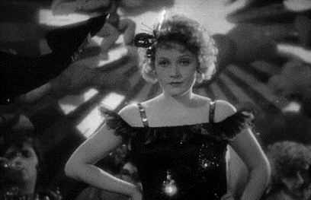
Who is this star and what was the name of her famous German film from 1930?
DANCE, DANCE, DANCE
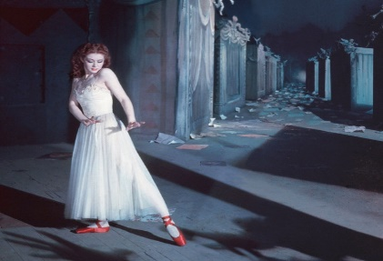
What was the name of this film and who was the female lead?

FOR VALOUR
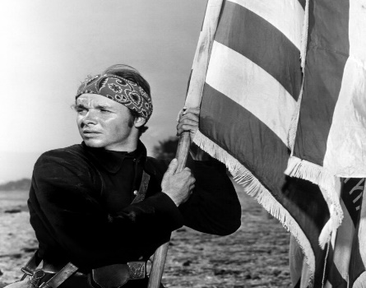
Who is this soldier who became an actor, and what was the name of his film with a colour in its title?
SINGIN’ THE BLUES?
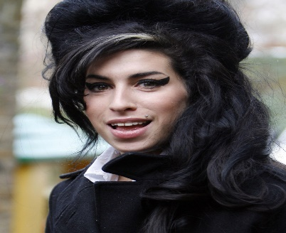
Who is the singer and what was the title of her hit single referring to a colour reversion?
VERY POPULAR STAR
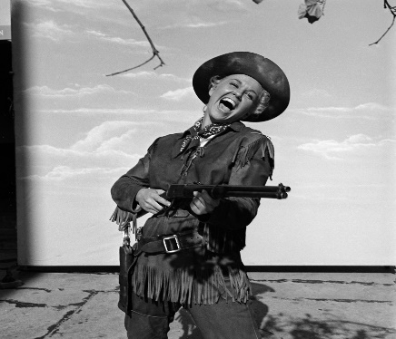
Who is she and which hills did she sing about in the film Calamity Jane?

50s STAR
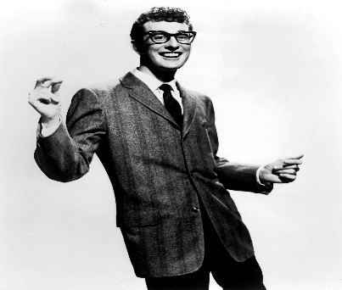
Who is the singer and which of his songs contained the words “Flying across the desert in a TWA, I saw a woman walking across the sand…...?”
FILM STARS?
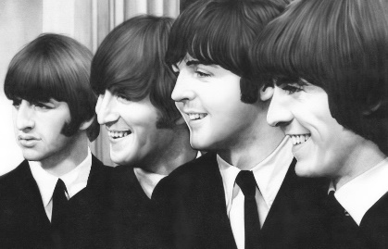
Which of their films contained the name of a colour?
WILDER BY THE MINUTE
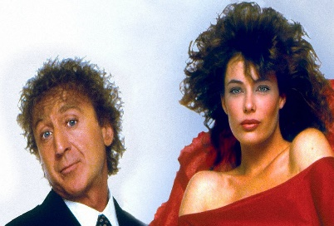
What was the name of this film and what was the Stevie Wonder hit associated with it?
MASTER OF HORROR
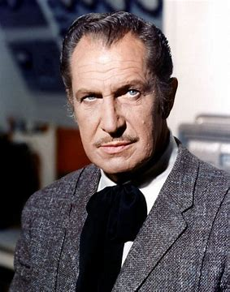
Who is he and what is the missing colour in the title of his 1964 film- The Masque of the * Death”?
DIAMOND GEEZERS?
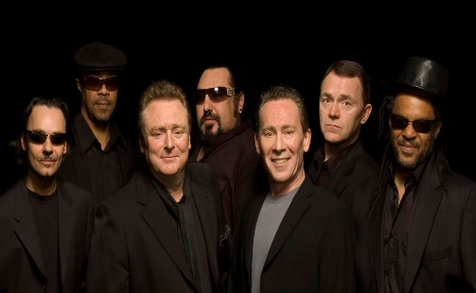
Who are these guys and what was the colour of the wine in their 1983 cover of a Neil Diamond hit?
MADE IT MA! TOP OF THE WORLD!
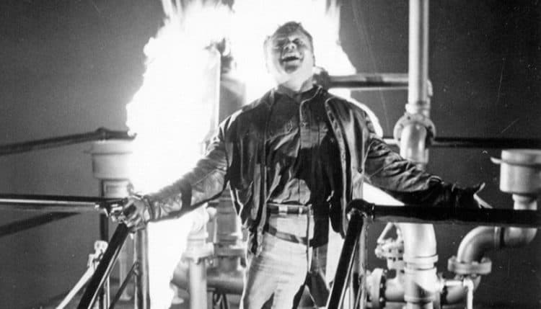
Who is the actor and which of his films is shown here?
MURDER SUSPECT
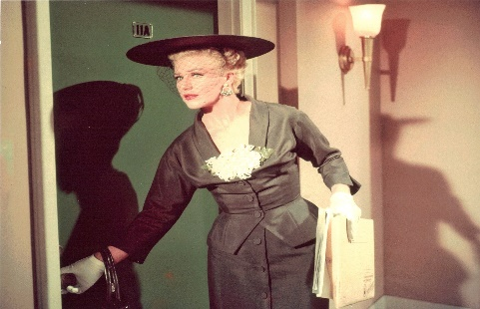
Who is this actress and what was the name of this film - Red Widow, Black Widow or Green Widow?
THE COLOUR OF LOVE?
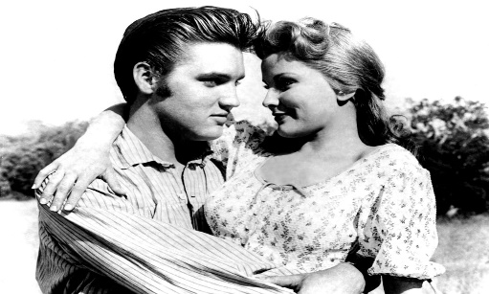
Which two Elvis Presley films have a colour in the title?
GRAVEYARD SEARCH
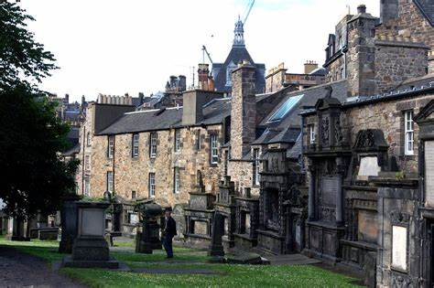
An Edinburgh churchyard features a nearby statue of a famous dog. The dog featured in a 1961 Walt Disney film. What was its name?
DREAMING?
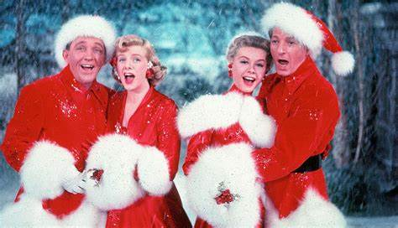
What is the name of the film and who are the four stars shown here?
EVENIN’ ALL
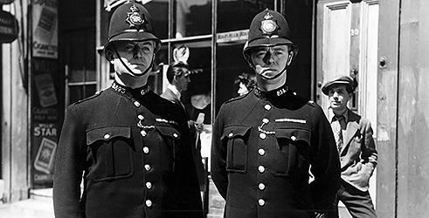
A 1950 film that starred Dirk Bogarde as a villain. Who is the actor on the left and which long-running TV series on BBC TV was developed from the film?
COLOURFUL STARS
Complete the names of these stars
JACK *
RICHARD *
CAROL *
COLOURFUL TITLES
What is the missing colour in these film titles?
1953 The * Beret
2002 *Dragon
1980 *Lagoon
1957 * Murder at St.Trinians
1992 *Men Can’t Jump
1999 The *Mile
TOP OF THE COLOURFUL POPS
Complete the title of these songs by adding a colour.
Mellow * (Donovan)
** Grass of Home (Tom Jones)
Tie a *Ribbon (Tony Orlando and Dawn)
*Bayou (Roy Orbison)
Big * Taxi (Joni Mitchell)
99 * Balloons (Nina)
Mr. * Skies (E.L.O.)
COLOURFUL GROUP
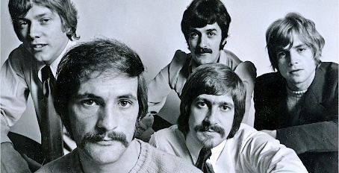
What is the name of this group seen here in 1968?
AS THEY ARE
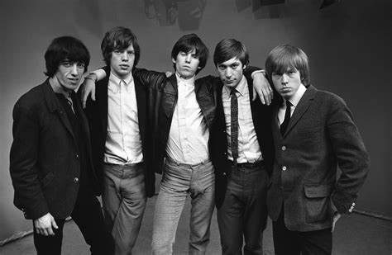
Which of their hits has the name of a colour in the title?

