Screen Memories Review
June 7th . 2021

THIS WEEK’S THEME
This week’s theme is Where Were You in ’62? We feature the films, the stars, the music and the fashions of the year 1962. Seems like yesterday.
THIS WEEK’S TRANSATLANTIC SESSIONS
We are having our first session with the Hummingbird Memory Café in New Mexico on Wednesday June 9th. They operate on Mountain Time and the start time is 8.00 p.m. in Scotland. I know that this is late for the Scottish groups, but the people in Hummingbird are so looking forward to meeting us. If you possibly can manage, you will be made most welcome.
DEMENTIA AWARENESS WEEK
We hosted a session during Alzheimer Scotland’s Dementia Awareness Week last Thursday, June 3rd. There were people who joined in from British Columbia, Texas and Massachusetts and we all had a great time judging remakes against originals. We needed VAR for the debate between Jerry Lee Lewis and Dolly Parton for the best version of Great Balls of Fire.
ON THE HOME FRONT
On Monday June 7th, we are hosting the monthly session with West Dunbartonshire starting at 3p.m.with a special focus on Film Musicals.

BORN IN 1963
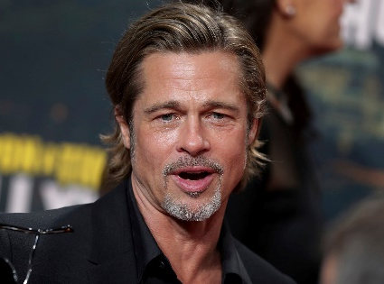
Do you recognise this star who was born in December 1963, the year of the Oscars ceremony for 1962?
I WILL ALWAYS LOVE YOU
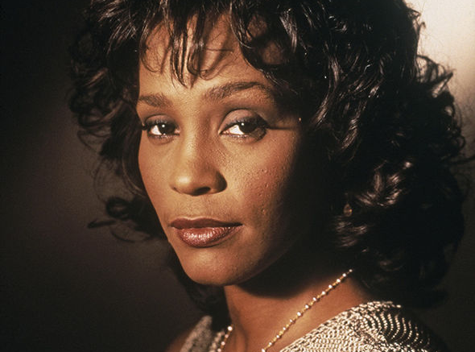
Also born in 1963, who is this American singer and actress? In which film did she sing the above theme song and who was her co-star?
HARSH LESSONS
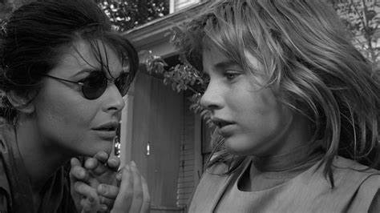
The actress in the dark glasses was one of the nominees for Best Actress at the 1963 Oscars. Who is she and what was the name of the film in which she starred? Which famous part did she play in The Graduate?
LEGENDARY STAR
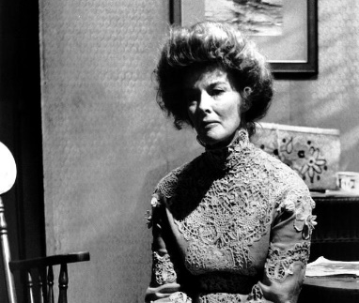
Another nominee for Best Actress. Who is she? She won the award on 4 occasions. Can you fill in the missing words in her Oscar-winning films?
Morning?
Guess Who’s Coming to?
The Lion in?
On Golden?
SCARY STUFF
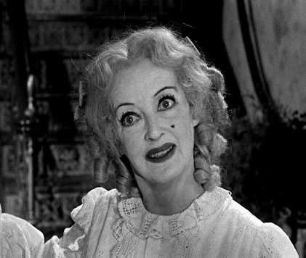
Another star from the Golden Age. Who is she and in which film is she shown here?
YES SIR, NO SIR
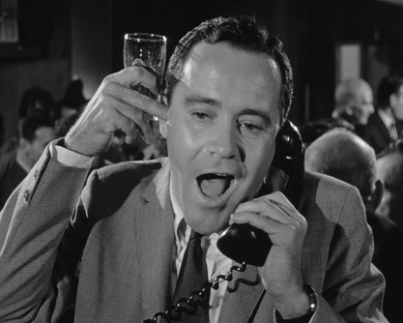
One of the candidates for the Best Actor award. Who is he?

OSCAR NOMINEE 1962
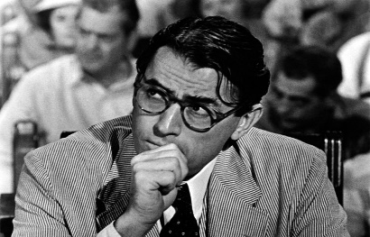
Who is this Oscar-nominated actor and what was the name of his character in To Kill a Mockingbird? For a bonus point, who wrote the book on which the film is based?
THE BIRDIE SONG?
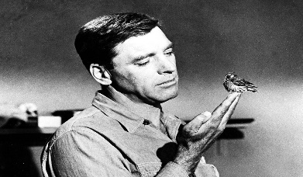
The film was The Birdman of Alcatraz. Who is the star? Which of his films was partly set in Scotland and involved a search for the Aurora Borealis?
THE BEST FILM OF 1962?
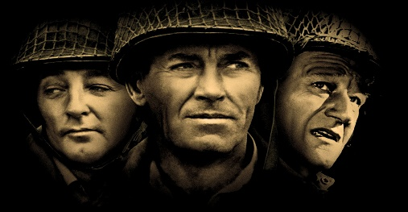
This Oscar-nominated film from 1962 had a stellar cast. Who are three of the cast shown here and what was the name of the film?
ANOTHER 1962 BEST FILM NOMINATION
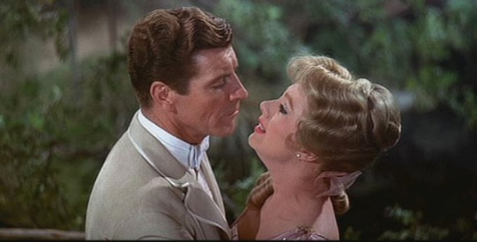
Who are these stars of The Music Man?

THE NAME’S BOND – JAMES BOND
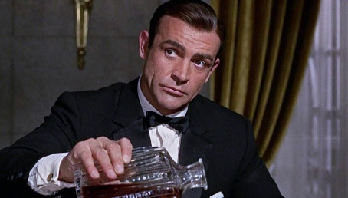
1962 saw the release of the first James Bond film. What was its title? Which characters were played by these actors?
SEAN CONNERY, JOSEPH WISEMAN, LOIS MAXWELL, BERNARD LEE.
WHEN IRISH EYES?
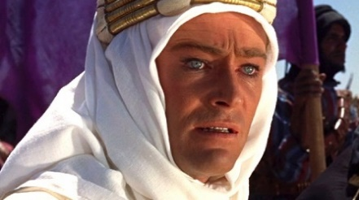
Who is this actor and in which 1962 film did he play the title role?
THE 1962 VERSION
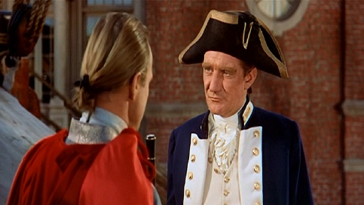
There are several versions of this film. What is its title and who are the two leading actors seen here in the 1962 version?
THE LONG DISTANCE RUNNER
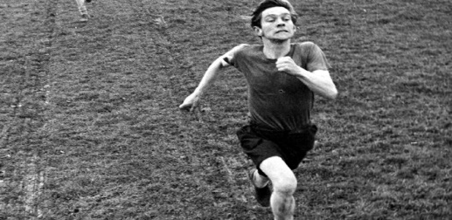
Who is this British actor who played the part of Colin Smith in the 1962 film The Loneliness of the Long Distance Runner?
WHO DUNNIT?
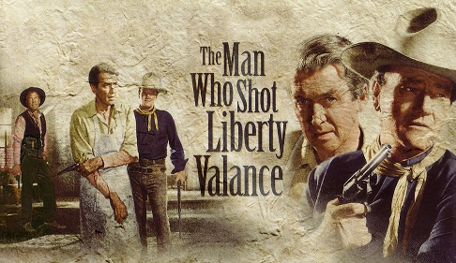
Who are the two stars on the right of the poster? Who sang the song of the same title?
THE ORIGINAL
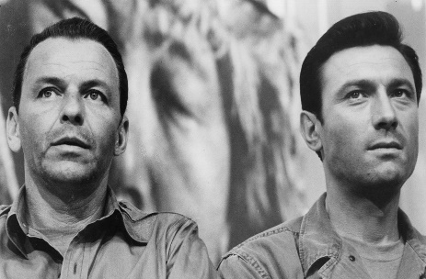
This film has been remade, but do you recognise the two stars of the original 1962 version?
SOCIAL REALISM
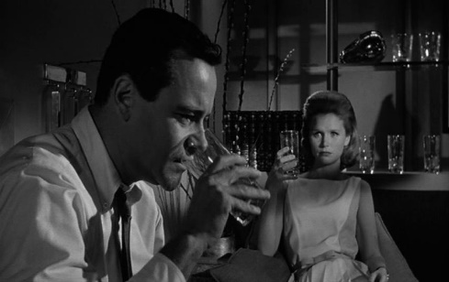
A hard-hitting portrayal of alcoholism in this 1962 film. Who are the two stars and what was the title of the film?
SCARY FILM
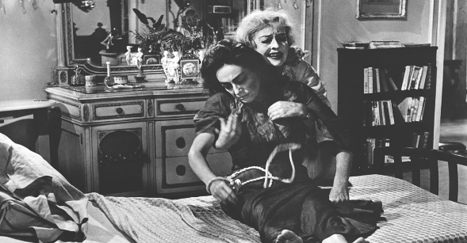
Who are the two stars shown here in a 1962 classic?
THE WORLD OF POP MUSIC – 1962 STYLE
BOBBING ALONG?
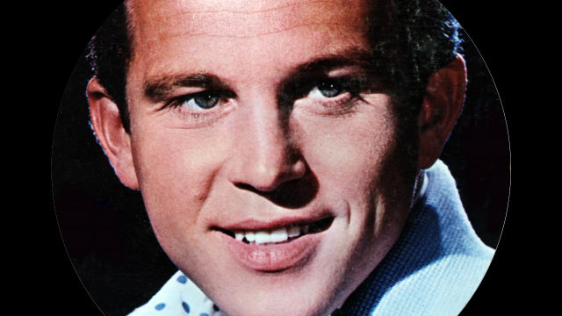
One of the many singers whose first name was Bobby. Who is he?
SEALED WITH A KISS?
His initials are B.H. and he had hits with love songs and a famous comedy record. Who is he and what was the comedy record?
ENGINEERING A HIT
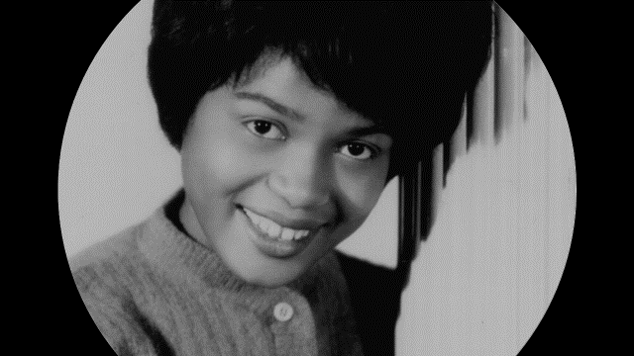
She worked for songwriter Carole King and had a massive hit in 1962 with a dance song. Who is she and what was the name of the dance?
1962 NUMBER ONES
Who had hits with these songs?
SHE’S NOT YOU, THE YOUNG ONES, I CAN’T STOP LOVING YOU, ROCK A HULA BABY,

GIRL POWER
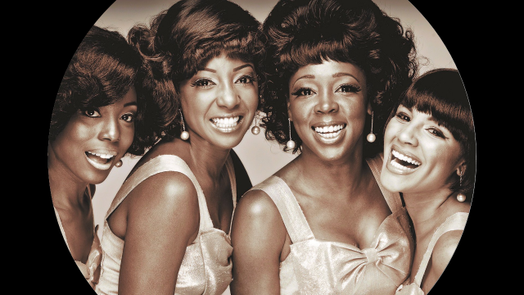
What is the name of this girl group and what was their big 1962 success all about a man in uniform?
JERSEY BOYS
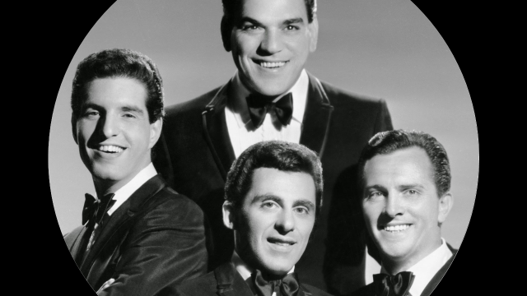
What is the name of this quartet and who was the lead singer?
YODELLING TIME
Who is this singer and was he born in Australia or England? He had three number one hits in a row. Do you recognise them from their initials?
I.R.Y.
L.B.
T.W.W.
MORE 1962 NUMBER ONES
Who had hits with these records?
NUT ROCKER, TELSTAR, COME OUTSIDE.

